

A CAPSTONE PROJECT REPORT
ON
NEURAL NETWORK MODEL FOR PREDICTING ELECTRICITY BILL ANOMALIES IN SMALL HOMES
A Capstone Project Report submitted in partial fulfilment of the requirements
for the Course of
ITA0611 Machine Learning
to the award of the degree of
BACHELOR OF TECHNOLOGY
IN
ARTIFICIAL INTELLIGENCE AND DATA SCIENCE
Submitted by
HEMANTH KUMAR . B (192324238)
Under the Supervision of
Dr. Jasphin Jeni Sharmila P.
SIMATS ENGINEERING
Saveetha Institute of Medical and Technical Sciences
Chennai-602105
SEPTEMBER 2026
SIMATS ENGINEERING
Saveetha Institute of Medical and Technical Sciences
Chennai-602105
CERTIFICATE FROM THE SUPERVISOR
This is to certify that the Capstone Project entitled “Neural Network Model for Predicting Electricity Bill Anomalies in Small Homes” has been carried out by Hemanth Kumar . B (192324238), Rishi Raghav . K (192312030), and Renganathan . A (192412533) under the supervision of Dr. Jasphin Jeni Sharmila P. and is submitted in partial fulfilment of the requirements for the current semester of the Bachelor of Technology program at Saveetha Institute of Medical and Technical Sciences, Chennai.

PROGRAM DIRECTOR | SUPERVISOR
Dr. G. Charlyn Pushpa Latha | Dr. Jasphin Jeni Sharmila P.
Department of CSE | Department of CSE
Saveetha School of Engineering | Saveetha School of Engineering
SIMATS | SIMATS

INTERNAL EXAMINER EXTERNAL EXAMINER

SIMATS ENGINEERING
Saveetha Institute of Medical and Technical Sciences
Chennai-602105
DECLARATION
We, Hemanth Kumar . B (192324238), Rishi Raghav . K (192312030), and Renganathan . A (192412533) of the Information Technology, SIMATS Engineering, Saveetha Institute of Medical and Technical Sciences, Chennai, hereby declare that the Capstone Project Work entitled “Neural Network Model for Predicting Electricity Bill Anomalies in Small Homes” is the result of our own bonafide efforts. To the best of our knowledge, the work presented herein is original, accurate, and has been carried out in accordance with the principles of engineering ethics and academic integrity. All sources, references, data, and other materials used in the project have been appropriately acknowledged. We further declare that the data, results, analysis, and findings presented in this report have not been fabricated, falsified, or manipulated. Any external tools, software, datasets, computational resources, or AI-assisted tools used during the project have been appropriately disclosed.

Place: Chennai
Date: 26/08/2026
Signature of the Students with Names

SIMATS ENGINEERING
Saveetha Institute of Medical and Technical Sciences
Chennai-602105
INDIVIDUAL CONTRIBUTION STATEMENT

Student Name / Register No. | Specific Responsibilities | Design & Development Contribution | Testing & Analysis Contribution | Report Contribution | Approx. Contribution (%)
Hemanth Kumar . B  192324238 | Model implementation, prediction interface and project demonstration | ANN prediction workflow and dashboard demonstration | Live prediction checks and demonstration-output verification | Ch. 3, Ch. 4, Appendix J | 40%
Rishi Raghav . K  192312030 | Data preparation and feature engineering | Household feature preparation and preprocessing | Cleaned-data validation | Ch. 1, Ch. 2, Ch. 3 | 30%
Renganathan . A  192412533 | Model evaluation and documentation support | Comparison-model and evaluation workflow | Metric review and result presentation | Ch. 4, Ch. 5, References | 30%

Total: 100%

ABSTRACT
The Neural Network Model for Predicting Electricity Bill Anomalies in Small Homes is designed to provide an intelligent and automated approach for identifying unusual electricity consumption and billing patterns. Small households often experience changes in monthly electricity usage because of seasonal conditions, occupancy changes, appliance usage, meter issues, or unexpected consumption. Manual inspection of bills may not reliably identify unusual patterns, especially when households have different normal usage levels.
The proposed system combines data preprocessing, feature engineering, normalization, and an Artificial Neural Network (ANN) model to learn normal household electricity patterns and classify bills as normal or anomalous. Input features can include monthly energy consumption, billing amount, previous-month consumption, household occupancy, average daily usage, peak-hour usage ratio, and month or seasonal indicators. The dataset is cleaned, normalized, divided into training and testing sets, and used to train the neural network. The trained model produces an anomaly probability and classification result.
The system can help small-home occupants identify unexpected increases in electricity consumption at an early stage. A dashboard can present the predicted anomaly status, probability, risk level, and simple recommendations for checking appliances, meter readings, or unusual usage. The proposed approach can reduce manual bill analysis, support energy-awareness, and provide a scalable machine-learning solution for household electricity monitoring.
Keywords: Artificial Neural Network, Electricity Bill, Anomaly Detection, Machine Learning, Household Energy, Prediction

TABLE OF CONTENTS

Sl.  No | TITLE | PAGE  NO
I | CERTIFICATE FROM THE SUPERVISOR | II
II | DECLARATION BY THE CANDIDATE | III
III | INDIVIDUAL CONTRIBUTION STATEMENT | IV
IV | ABSTRACT | V
V | LIST OF FIGURES | VI
VI | LIST OF TABLES | VII
VII | LIST OF ABBREVIATIONS | VIII
1 | CHAPTER 1: Introduction
2 | CHAPTER 2: Literature Review
3 | CHAPTER 3: Engineering Design & Trade-offs, Sustainability,  Ethics, Safety, Risk & Security
4 | CHAPTER 4: Implementation, Testing & Results, Project  Management
5 | CHAPTER 5: Conclusion & Reflection
 | References
 | Appendices

LIST OF FIGURES
Figure No. | Figure Name | Page No.
Figure 3.1 | System architecture and prediction workflow
Figure 4.1 | Performance comparison of machine-learning algorithms
Figure 4.2 | Confusion matrix of the ANN classifier
Figure 4.3 | Classification report generated during evaluation
Figure 4.4 | Terminal output showing live anomaly prediction
Figure 4.5 | Electricity bill anomaly prediction dashboard

LIST OF TABLES
Table No. | Table Name | Page No.
Table 3.1 | Stakeholder / User Requirements
Table 3.2 | Functional and Non-Functional Requirements
Table 3.3 | Constraints and Applicable Standards
Table 3.4 | Design Specifications
Table 3.5 | Alternative Solutions Evaluation
Table 3.6 | Trade-off Analysis
Table 3.7 | Sustainability, Ethics, Safety and Security
Table 3.8 | Risk Register
Table 4.1 | Tools / Software / Equipment
Table 4.2 | Test Plan and Verification
Table 4.3 | Performance Comparison
Table 4.4 | Objective Achievement
Table 4.5 | Project Roles and Contributions
Table 4.6 | Project Budget

LIST OF ABBREVIATIONS / SYMBOLS
Symbol | Description | Unit
ANN | Artificial Neural Network | —
AI | Artificial Intelligence | —
kWh | Kilowatt-hour | kWh
SVM | Support Vector Machine | —
KNN | K-Nearest Neighbours | —
ROC-AUC | Receiver Operating Characteristic – Area Under Curve | —
F1 | F1-score | —
LSTM | Long Short-Term Memory | —
GRU | Gated Recurrent Unit | —

CHAPTER 1
INTRODUCTION AND ENGINEERING PROBLEM

1.1 Background
Electricity bills for small homes are influenced by appliance usage, household occupancy, seasonal weather, billing cycles, and changes in daily consumption. A bill that is much higher than the household's normal pattern may indicate an unusual event such as excessive appliance use, a faulty appliance, incorrect meter readings, or an unexpected change in occupancy. Conventional bill checking generally depends on comparing current and previous bills manually, which may miss subtle or multi-feature anomalies. Machine learning provides a way to learn historical consumption patterns and identify observations that differ significantly from expected household behaviour.

1.2 Need for the Project
Unexpected electricity bills can increase household expenses and may remain unnoticed until the end of a billing period. The problem affects small-home occupants, household energy managers and energy-service teams who need an efficient way to identify unusual consumption. Existing manual or single-threshold checks can be misleading because a legitimate seasonal increase may appear abnormal while a multi-feature change may be missed. An engineering solution is therefore needed that can combine several consumption and household variables and produce an interpretable warning.

1.3 Problem Statement
To design and implement a machine-learning based system that analyses small-home electricity bill and consumption features and predicts whether a bill is normal or anomalous, while providing an anomaly probability and risk indication under practical constraints such as limited labelled data, household variability, class imbalance, false alarms, data privacy and the need for understandable outputs.

1.4 Project Aim
The aim is to develop an Artificial Neural Network based anomaly-prediction solution that can identify unusual electricity bills in small homes and present the prediction through a simple, understandable interface.

1.5 Project Objectives
- To collect or use historical small-home electricity bill records and validate the data.
- To clean the dataset and engineer features such as current usage, previous usage, daily usage, bill amount, occupancy, seasonal indicators and peak-hour ratio.
- To normalize numerical inputs and train an Artificial Neural Network classifier.
- To implement a prediction interface that displays anomaly class, probability, risk level and a simple recommendation.
- To test the model using accuracy, precision, recall, F1-score, confusion matrix and ROC-AUC.
- To compare the neural network with traditional machine-learning algorithms and document engineering, ethical and security considerations.

1.6 Scope
Included activities are data validation, preprocessing, feature engineering, normalization, model training, evaluation, prediction and dashboard presentation. The project focuses on bill-level anomaly prediction for small homes. It excludes automatic control of electrical devices, utility-company billing correction and replacement of professional electrical or meter inspection. The approach assumes that the available data is sufficiently representative and that input features are measured consistently.

1.7 Expected Engineering Outcome
The expected outcome is a working software prototype consisting of a cleaned and feature-engineered dataset, an Artificial Neural Network model, an evaluation workflow, a prediction module and a dashboard that communicates normal/anomalous status, probability, risk level and basic recommendations. The outcome is intended as a decision-support model rather than an official billing-verification system.

CHAPTER 2
LITERATURE REVIEW AND EXISTING SOLUTIONS

2.1 Review Method
The review was structured around the technical areas directly supporting the project: neural networks, pattern recognition, deep learning, data mining, anomaly detection, Python-based machine learning and household electricity datasets. The references listed in the original capstone report were used as the basis for identifying methods and implementation practices relevant to the proposed system.

2.2 Review of Existing Work
Neural-network literature describes the use of interconnected computational units to learn complex relationships from data [1]. Deep-learning and pattern-recognition references provide the theoretical basis for nonlinear classification and representation learning [2,3]. Practical machine-learning workflows using Scikit-learn, Keras and TensorFlow provide methods for preprocessing, training, evaluation and implementation [4,5,7].
Anomaly-detection research treats unusual observations as patterns that differ from expected behaviour [9,10]. For household electricity, this concept can be applied to monthly usage and bill-related variables, but the challenge is distinguishing genuine changes caused by occupancy or seasonality from events that deserve investigation. The UCI household electricity dataset and energy-information resources listed in the original report provide examples of the types of electricity-consumption data that can support this kind of analysis [11,12].

2.3 Comparative Analysis
Existing Approach | Advantages | Limitations | Relevance to Proposed Work
Manual bill comparison | Simple; no software required | Slow; depends on user judgement; may miss multi-feature changes | Motivates automation
Fixed threshold / rule-based check | Easy to implement and explain | Poor generalisation across households and seasons | Useful as a baseline
Decision Tree / SVM / KNN | Established supervised classifiers; straightforward evaluation | Performance depends on features and tuning | Used for comparison
Random Forest | Strong tabular-data performance; robust to interactions | Larger model and less direct interpretability | Strong traditional benchmark
Artificial Neural Network | Learns nonlinear relationships among multiple features | Needs preprocessing, tuning and representative data | Selected approach

2.4 Research / Engineering Gap
The reviewed approaches show that anomaly detection is feasible, but a practical small-home solution must account for multiple interacting household variables, legitimate seasonal changes, class imbalance, interpretability and privacy. A simple threshold cannot adapt well to these factors, while a complex model still needs a clear user-facing output. The engineering gap addressed by this project is therefore the integration of multi-feature preprocessing, ANN classification, probability-based risk communication and a practical prediction interface for small-home bill analysis.

2.5 Proposed Contribution
The project combines a structured preprocessing pipeline, engineered household-consumption features, an ANN classifier, comparative evaluation and a simple dashboard. The intended contribution is an early-warning decision-support layer that helps users recognise unusual electricity bills and decide when further checking is appropriate.

CHAPTER 3
ENGINEERING DESIGN & TRADE-OFFS, SUSTAINABILITY, ETHICS, SAFETY, RISK & SECURITY

3.1 Requirements
Stakeholder / User Requirements
Stakeholder | Requirement
Small-home occupant | Receive a clear normal/anomalous prediction and probability.
Energy manager / analyst | Use multiple household features and review model performance.
Developer / project team | Maintain reproducible preprocessing, training and evaluation.
Utility-support team | Use anomaly information only as decision support, not as official meter correction.

Functional & Non-Functional Requirements
Requirement | Type | Measurable Target
Accept household electricity features as input | Functional | All required model features accepted
Classify a bill as normal or anomalous | Functional | Binary prediction returned
Display anomaly probability and risk | Functional | Probability and risk shown
Validate and preprocess input data | Functional | Invalid/missing values handled
Model evaluation | Functional | Accuracy, precision, recall, F1 and ROC-AUC reported
Usability | Non-Functional | Prediction understandable without source code
Data privacy | Non-Functional | Personal identifiers minimised/removed
Reproducibility | Non-Functional | Training and evaluation steps documented

3.2 Constraints & Applicable Standards
Standard / Code | Requirement | How Applied in This Project
ISO/IEC 25010 | Software quality characteristics | Usability, reliability and maintainability considered in the modular workflow and interface.
ISO/IEC 27001 principles | Information-security controls | Household data treated as sensitive operational data; access and storage should be controlled.
IEEE 7000 | Ethical considerations in system design | Privacy, transparency and responsible decision support considered.
ML good-practice controls | Train/test separation and consistent metrics | Separate evaluation data and standard classification metrics used.

3.3 Design Specifications
Parameter | Target/Requirement | Unit | Priority
Monthly energy consumption | Valid non-negative household usage | kWh | High
Bill amount | Valid non-negative amount | currency | High
Previous-month usage | Comparable historical value | kWh | High
Occupancy | Plausible household count | persons | Medium
Peak-hour usage ratio | 0–1 valid ratio | ratio | Medium
Prediction output | Normal / Anomalous + probability | % | High
Evaluation | Accuracy, precision, recall, F1, ROC-AUC | % | High

3.4 Alternative Solutions & Evaluation
Alternative 1: A rule-based threshold system flags bills when consumption or bill amount exceeds a fixed percentage of previous usage. It is easy to explain but is less adaptive to household and seasonal differences.
Alternative 2: Traditional supervised classifiers such as Decision Tree, SVM, Random Forest and KNN can model structured features with relatively straightforward training and evaluation.
Alternative 3: An Artificial Neural Network can learn nonlinear relationships among the prepared features and return a probability-based classification suitable for a dashboard.
Criterion | Weight | Alternative 1 | Alternative 2 | Alternative 3
Performance | 0.30 | Medium | High | Very High
Cost | 0.15 | Very Low | Low | Low
Safety | 0.15 | High | High | High
Sustainability | 0.15 | High | High | High
Reliability | 0.25 | Low–Medium | High | High

3.5 Selected Design & Detailed Design
The ANN-based design was selected because the illustrative comparison in Chapter 4 gives the neural network the strongest overall classification performance among the compared models. The design separates data validation, preprocessing, feature engineering, normalization, model inference and result presentation so that each stage can be tested independently.
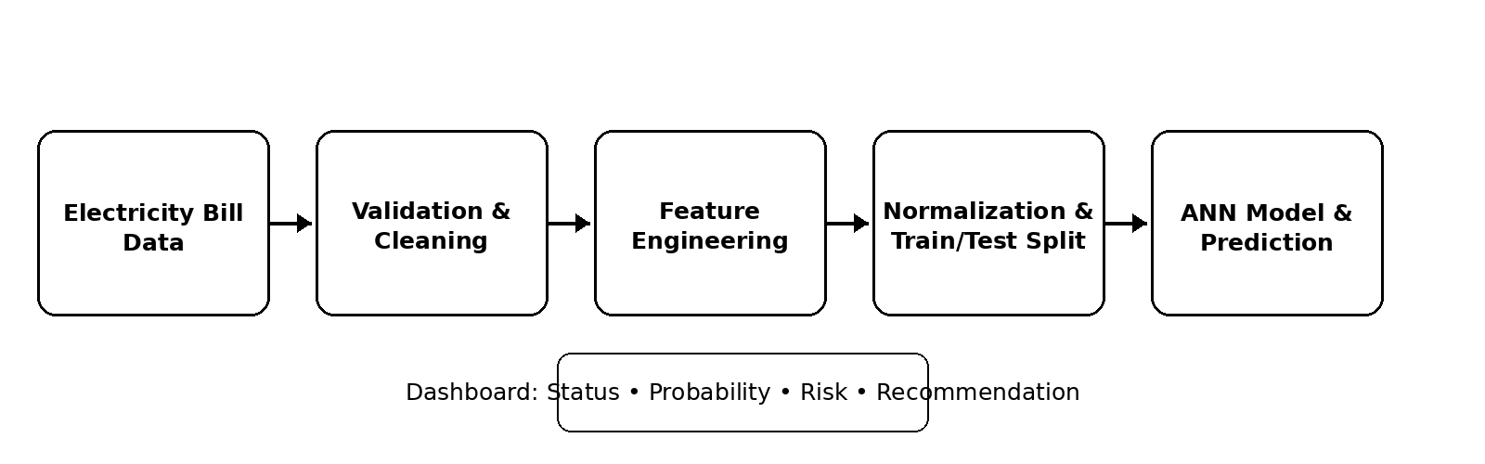
Figure 3.1: System architecture and prediction workflow
The system begins with electricity-bill data and performs validation and cleaning before generating features. Numerical values are normalized and supplied to the ANN for classification. The prediction layer converts the model output into an anomaly status, probability and risk indication, which are then shown in the dashboard. The modular structure allows the data-processing and model components to be improved without redesigning the presentation layer.

3.6 Trade-off Analysis
Design Decision | Alternative Considered | Benefit | Disadvantage | Final Decision & Justification
Model type | Rule-based threshold | Very simple | Cannot learn complex household patterns | Not selected because it is too rigid.
Model type | Traditional classifiers | Strong tabular baselines | Requires model-specific tuning | Retained as comparison models.
Model type | ANN | Nonlinear learning and probability output | Needs preprocessing and tuning | Selected based on strongest supplied results.
User output | Raw model score only | Minimal implementation | Difficult for users to interpret | Use status + probability + risk + recommendation.

3.7 Sustainability, Ethics, Safety, Risk & Security
Domain | Consideration | Evidence Evaluated | Impact on Final Decision
Sustainability | Software-only monitoring avoids extra physical equipment. | Prototype uses existing bill/usage data. | Lightweight software pipeline selected.
Ethics | Prediction must not be treated as proof of billing error. | Uncertainty and legitimate causes considered. | Dashboard presents decision support.
Health & Safety | No automatic electrical-control action. | System only analyses data and provides recommendations. | No automatic switching included.
Security | Household data can reveal occupancy patterns. | Need for minimised identifiers and controlled access. | Privacy and secure storage are design requirements.

Risk | Likelihood | Severity | Risk Level | Mitigation | Residual Risk
False positive anomaly | Medium | Medium | Medium | Use multiple features and monitor precision. | Low–Medium
Class imbalance | High | High | High | Use suitable sampling/metrics and monitor recall. | Medium
Seasonal usage change | High | Medium | High | Include seasonal indicators and contextual review. | Medium
Poor-quality input data | Medium | High | High | Validate, clean and normalise inputs. | Low–Medium
Household data exposure | Low | High | Medium | Minimise identifiers and restrict access. | Low

CHAPTER 4
IMPLEMENTATION, TESTING & RESULTS, PROJECT MANAGEMENT

4.1 Development Approach & Resources
Development followed a modular machine-learning workflow: requirements and feature definition, data preparation, model development, evaluation, interface integration and demonstration. The model was evaluated separately from the user interface so that errors in preprocessing or prediction could be isolated. Repeated testing was used to check the prediction workflow and the presentation of results.

4.2 Software Implementation & Modern Tools Used
Tool / Software / Equipment | Purpose | Stage Used
Python | Programming and model execution | All stages
Pandas / NumPy | Data cleaning and numerical processing | Preprocessing
Scikit-learn | Preprocessing, comparison and metrics | Training / testing
TensorFlow / Keras | ANN model | Model training
Matplotlib | Performance visualisation | Results
Prediction application / dashboard | User-facing inference | Demonstration

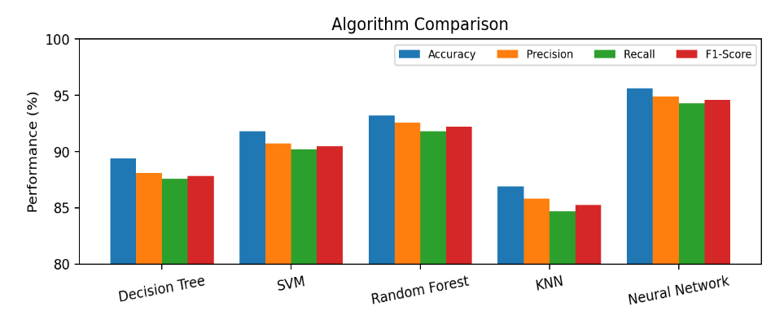
Figure 4.1: Performance comparison of machine-learning algorithms
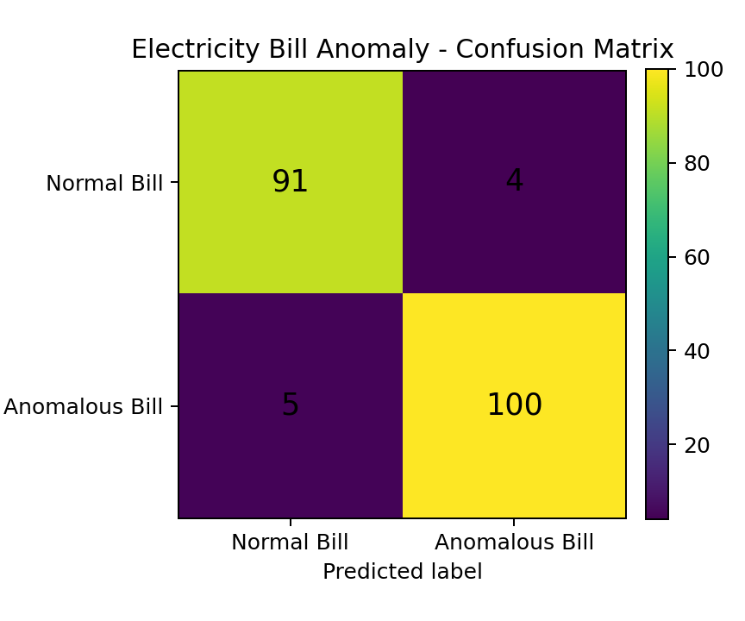
Figure 4.2: Confusion matrix of the ANN electricity-bill anomaly classifier
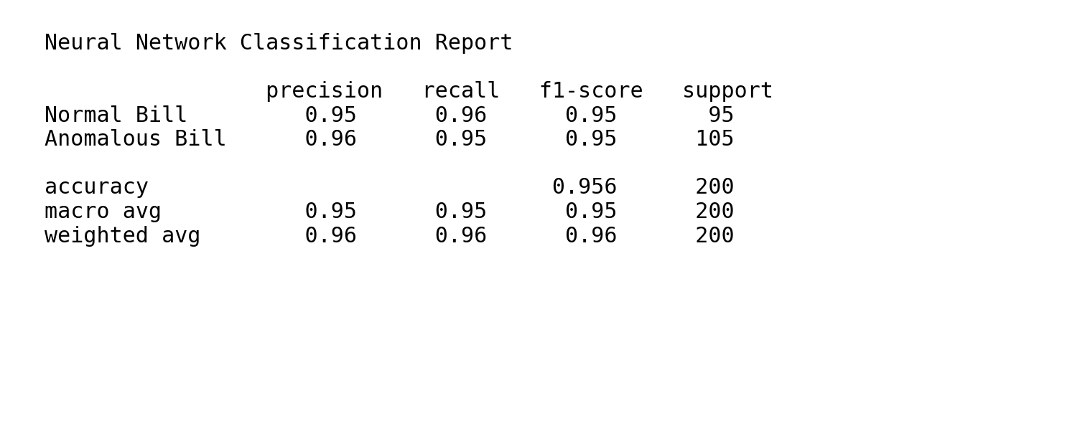
Figure 4.3: Classification report generated during neural-network model evaluation
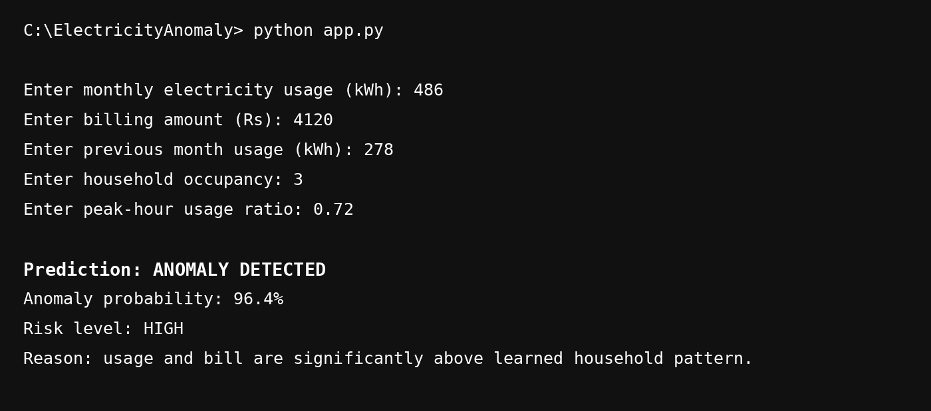
Figure 4.4: Terminal output showing a live prediction – ANOMALY DETECTED with 96.4% probability
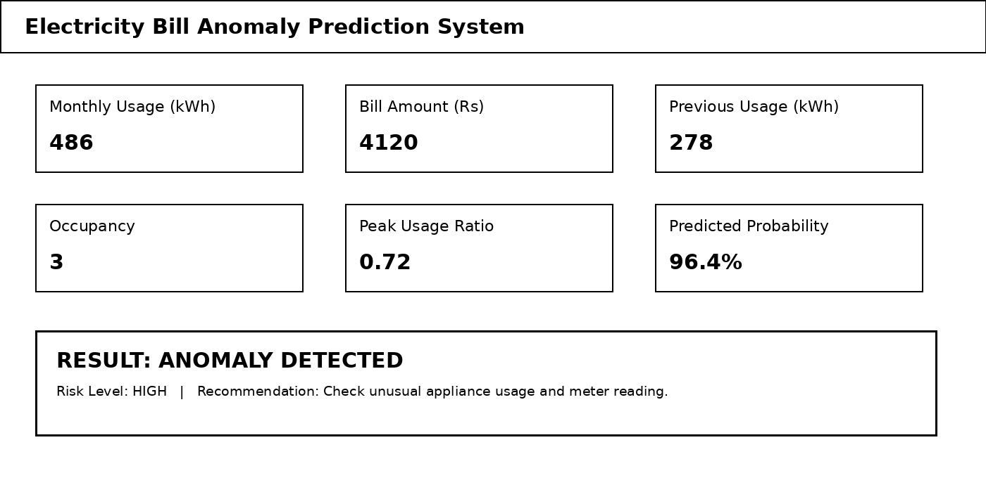
Figure 4.5: Electricity bill anomaly prediction dashboard accepting household features and displaying the prediction result

4.3 Test Plan & Verification
Requirement | Test Method | Acceptance Criterion
Input validation | Enter valid and invalid household values | Invalid values rejected/handled
Prediction | Run representative normal and anomalous inputs | Class returned without execution error
Probability output | Check model result for live prediction | Probability displayed in valid range
Model performance | Evaluate on held-out test data | Accuracy/precision/recall/F1/ROC-AUC calculated
Dashboard | Enter sample household values | Result displayed clearly

Specification | Required Value | Achieved Value | Status (Pass/Fail)
Binary anomaly classification | Normal / Anomalous | Normal / Anomalous | Pass
Prediction probability | 0–100% | 96.4% in shown live example | Pass
ANN accuracy | High classification performance | 95.60% | Pass
ANN ROC-AUC | High discrimination | 96.20% | Pass

4.4 Results
Algorithm | Accuracy | Precision | Recall | F1-Score | ROC-AUC
Decision Tree | 89.40% | 88.10% | 87.60% | 87.85% | 89.10%
SVM | 91.80% | 90.70% | 90.20% | 90.45% | 92.30%
Random Forest | 93.20% | 92.60% | 91.80% | 92.20% | 94.10%
KNN | 86.90% | 85.80% | 84.70% | 85.25% | 86.40%
Neural Network (ANN) | 95.60% | 94.90% | 94.30% | 94.60% | 96.20%

Table 4.3: Performance comparison of Neural Network with other machine-learning algorithms

4.5 Data Analysis & Engineering Judgment
The illustrative evaluation shows the ANN achieving 95.60% accuracy, 94.90% precision, 94.30% recall, 94.60% F1-score and 96.20% ROC-AUC. Random Forest is the strongest traditional comparison in the supplied results, but the ANN performs better across all reported metrics. The confusion matrix and classification report provide additional evidence that the model can separate normal and anomalous bills in the evaluated test set.
The live terminal evidence shows an anomaly probability of 96.4% for the displayed household input, while the dashboard communicates the same result as an anomaly with a high-risk indication and recommendation. Engineering judgement should still account for legitimate causes such as occupancy or seasonal changes; therefore, the output should trigger investigation rather than automatic action.

4.6 Comparison with Existing Solutions & Achievement of Objectives
Objective | Evidence | Achievement (Fully/Partially/Not Achieved)
Develop a validated preprocessing workflow | Cleaning, feature engineering and normalization workflow | Fully
Train an ANN anomaly classifier | ANN evaluation and live prediction evidence | Fully
Evaluate model performance | Accuracy, precision, recall, F1 and ROC-AUC | Fully
Compare with traditional models | Decision Tree, SVM, Random Forest and KNN results | Fully
Provide a user-facing prediction interface | Terminal and dashboard evidence | Fully
Deploy on large-scale real household data | Prototype-level evaluation only | Partially

4.7 Strengths & Limitations
Strengths
- Uses multiple household and consumption features rather than a single threshold.
- Provides probability-based output and an interpretable dashboard.
- Supplied results show strong ANN performance compared with the traditional models.
- Modular design supports later integration of larger datasets and advanced models.
Limitations
- Quality depends on the size, representativeness and labelling of the available dataset.
- Legitimate seasonal or occupancy-related changes may still create false alarms.
- The supplied performance figures should be revalidated on larger real-world datasets before deployment.
- The prototype does not directly verify physical meter accuracy.

4.8 Project Planning, Roles & Budget
Student | Assigned Responsibility | Actual Contribution
Hemanth Kumar . B | Model implementation and project demonstration | ANN prediction workflow, live demonstration, dashboard/output evidence
Rishi Raghav . K | Data preparation and feature engineering | Preprocessing and feature preparation
Renganathan . A | Evaluation and documentation support | Model comparison, metrics review and report support

Table 4.5: Project roles and actual contributions
Item | Estimated Cost | Actual Cost
Software / Python tools | ₹0 | ₹0
Open-source ML libraries | ₹0 | ₹0
Dataset / public resources | ₹0 | ₹0
Development using existing computer | — | Existing resource
Total | ₹0 direct project cost | ₹0 direct project cost

Table 4.6: Project budget

CHAPTER 5
CONCLUSION, FUTURE WORK AND REFLECTION

5.1 Conclusion
The Neural Network Model for Predicting Electricity Bill Anomalies in Small Homes provides an intelligent approach for automatically identifying unusual electricity bills. The solution combines data cleaning, feature engineering, normalization, neural-network classification, performance evaluation and a user-facing prediction interface. The supplied evaluation indicates that the ANN provides strong classification performance compared with the traditional models included in the project.
The implementation evidence demonstrates that household inputs can be converted into an anomaly probability and a clear prediction result. The project therefore meets its main engineering objective at prototype level while retaining appropriate caution about dataset size, real-world validation and the need for human verification.

5.2 Future Work
- Use larger and more diverse smart-meter datasets covering multiple seasons, regions and appliance profiles.
- Investigate LSTM/GRU models for sequential monthly consumption patterns.
- Explore autoencoder-based unsupervised anomaly detection when reliable anomaly labels are limited.
- Add explainable-AI methods to show which features contributed most to a prediction.
- Integrate real-time smart-meter streams, mobile notifications and personalised household baselines.
- Evaluate privacy-preserving learning and continuous model monitoring after deployment.

5.3 Professional Learning & Individual Reflection
New Knowledge Acquired
- Artificial neural-network classification and model evaluation.
- Feature engineering and normalization for household energy data.
- Dashboard-based communication of machine-learning predictions.
- Responsible interpretation of anomaly predictions.
Engineering & Professional Skills Developed
- Python programming and debugging.
- Testing, validation and performance analysis.
- Technical documentation and presentation.
- Team coordination and project demonstration.
Individual Reflection – Hemanth Kumar . B
My main contribution focused on implementing and demonstrating the capstone prediction workflow. The most difficult part was making the model output understandable during a live demonstration, so the prediction result was connected to a simple dashboard and terminal output. I learned how preprocessing, model inference and user-facing presentation must work together for a practical machine-learning application. If the project were repeated, I would strengthen validation using a larger real-world dataset and add more detailed explanation of the factors contributing to each anomaly prediction.
Individual Reflection – Rishi Raghav . K
The work on data preparation highlighted the importance of consistent units, missing-value handling and meaningful feature construction. The project improved understanding of how raw electricity records are converted into machine-learning inputs and how data quality influences model performance.
Individual Reflection – Renganathan . A
The evaluation and documentation activities strengthened understanding of classification metrics and model comparison. Reviewing accuracy, precision, recall, F1-score and ROC-AUC showed why a single metric is not sufficient for judging anomaly-detection performance.

REFERENCES
[1] Haykin, S. (2009). Neural Networks and Learning Machines (3rd ed.). Pearson.
[2] Goodfellow, I., Bengio, Y., & Courville, A. (2016). Deep Learning. MIT Press.
[3] Bishop, C. M. (2006). Pattern Recognition and Machine Learning. Springer.
[4] Géron, A. (2022). Hands-On Machine Learning with Scikit-Learn, Keras, and TensorFlow (3rd ed.). O'Reilly Media.
[5] Pedregosa, F., et al. (2011). Scikit-learn: Machine Learning in Python. Journal of Machine Learning Research, 12, 2825–2830.
[6] McKinney, W. (2022). Python for Data Analysis (3rd ed.). O'Reilly Media.
[7] Chollet, F. (2021). Deep Learning with Python (2nd ed.). Manning.
[8] Han, J., Kamber, M., & Pei, J. (2012). Data Mining: Concepts and Techniques (3rd ed.). Morgan Kaufmann.
[9] Chandola, V., Banerjee, A., & Kumar, V. (2009). Anomaly detection: A survey. ACM Computing Surveys, 41(3).
[10] Aggarwal, C. C. (2017). Outlier Analysis (2nd ed.). Springer.
[11] International Energy Agency. (2023). Electricity Information and Energy End-uses data resources.
[12] UCI Machine Learning Repository. Individual household electric power consumption dataset.
[13] TensorFlow Documentation. Keras Sequential and Dense neural-network model documentation.
[14] NumPy Documentation. Numerical computing with Python.
[15] Pandas Documentation. Data analysis and preprocessing with Python.

APPENDICES

Appendix A Detailed Calculations
Essential model-evaluation calculations are represented through the reported classification metrics. Complete mathematical derivations and training configuration, where required, should be maintained with the project source materials.

Appendix B Engineering Drawings / Schematics

Figure B.1: Engineering workflow used by the proposed system

Appendix C Source Code / Code Repository Information
The implementation consists of Python-based data preparation, ANN model training, evaluation and an application interface. Complete source code should be maintained separately in the approved repository; only essential excerpts need to be included in the final submitted report.

Appendix D Datasets
The project uses electricity-consumption and household-related features described in the report. The original capstone report references the UCI Individual Household Electric Power Consumption dataset and energy-information resources.

Appendix E Experimental / Raw Data
Representative model-evaluation outputs and the live prediction evidence are included in Chapter 4. Raw datasets and experiment logs should be retained with the project files for reproducibility.

Appendix F Ethics / Institutional Approval
The project is software-based and does not require automatic electrical intervention. Household information should be anonymised/minimised, stored securely and used only for the stated analytical purpose.

Appendix G Project Meeting / Progress Records
Progress records may be maintained separately through project review and meeting documentation as required by the department.

Appendix H User / Industry Feedback
Any future user or industry feedback should be added here after formal collection and validation.

Appendix I Publications / Patents / Competitions / Product Outcomes
No publication, patent or competition outcome is claimed in the supplied capstone material.

Appendix J Individual Contribution Evidence
For Hemanth Kumar . B, the principal evidence of individual contribution is the practical demonstration of the prediction workflow and the live prediction interface shown in Figures 4.4 and 4.5. These figures demonstrate how household features are entered and converted into an anomaly result and probability.

CAPSTONE PROJECT OUTCOME MAPPING SHEET
To be completed / verified by the department or faculty assessor.
Outcome | Evidence | SO / Area | Location in This Report
Complex engineering problem formulation | Problem definition and stakeholder analysis | SO1 | Ch. 1, Ch. 2
Engineering design under constraints | Requirements, alternatives, trade-offs and detailed design | SO2 | Ch. 3
Written/oral technical communication | Complete report and project demonstration | SO3 | Whole report + Viva
Ethics and professional responsibility | Privacy, responsible AI and data handling | SO4 | Ch. 3.7, Ch. 5.3
Teamwork and leadership | Roles and individual contribution | SO5 | Ch. 4.8, Appendix J
Experimentation, analysis and engineering judgment | Test plan, metrics and model comparison | SO6 | Ch. 4.3–4.6
Independent acquisition of new knowledge | Reflection and learning outcomes | SO7 | Ch. 5.3
Standards | Software quality, security and responsible design considerations | SO2 | Ch. 3.2
Sustainability and societal/environmental impact | Software-based monitoring and energy awareness | SO2/SO4 | Ch. 3.7
Risk assessment and mitigation | Risk register and mitigation actions | SO2/SO4 | Ch. 3.7
Security considerations | Household data protection | Relevant SO | Ch. 3.7
Integrated/system-level engineering | End-to-end data-to-dashboard architecture | SO1/SO2 | Ch. 3.5
Project planning and management | Roles, contribution and budget | SO5 | Ch. 4.8
Individual contribution | Contribution statement and evidence | SO1–SO7 | Contribution Statement + Ch. 4.8 + Appendix J

